JAMMU DISTRICT COLLEGES DATA

1.THE BUSSINESS SCHOOL ,UNIVERSITY OF JAMMU
- Website:TBS website
- Email:vershamehta@jammuuniversity.in
- Phone:0191-2430023
Key Details
- ESTABLISHED :Founded in 1987.
- TUITION FEE : ₹ 78,000 - ₹ 78,241 for the total duration of the 2-year course
- Accreditation:Recognized by UGC and AICTE.
- Vision:To be a leading center of excellence in management education, teaching, and research.
Programs
- MBA (Master of Business Administration):A two-year full-time program in Business Administration.
- Ph.D. (Management Studies):A three-year doctoral program for postgraduates.
Eligibility and Admissions
- Education:A Bachelor's degree with at least 50% marks is required for MBA and PGDM programs.
- Exams:Admission to MBA is based on CAT/MAT scores.
- Application:Admissions are conducted online via the official website.
Infrastructure
- Facilities:Includes a well-equipped computer lab with internet and video conferencing facilities.
- Library:Houses over 14,000 books and related literature on management.
- Other Amenities:Offers medical facilities, hostel accommodation, a playground, and a cafeteria.
Rankings & Awards
- Recognized as an A+ category B-School in the 2009 Business India Survey.
- Received the Dewang Mehta Excellence in Education Award in 2009 and 2012 for leadership and innovation.
IMAGE : https://share.google/images/PtQRXcWyc5kHrTYO3
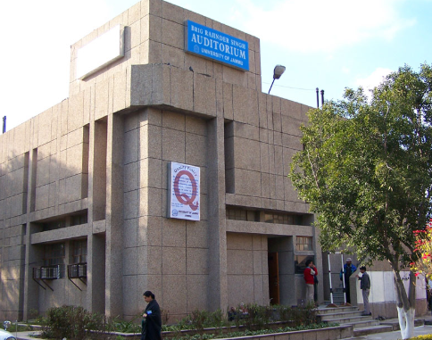

2. MODEL INSTITUTE OF ENGINEERING AND TECHNOLOGY
- Establishment:1996
- TUITION FEE :
- B.E./B.Tech:Fees range from approximately ₹1.1 Lakhs to ₹2.3 Lakhs.
- BCA (Hons.):Around ₹78,700.
- B.Com (Hons.):Around ₹78,700.
- BBA LL.B. (Hons.):Approximately ₹90,200.
- Affiliation:University of Jammu
- Approvals:UGC, AICTE, Bar Council of India
- Accreditation:NAAC 'A' Grade, NBA for CSE and MBA
- Rankings:ARIIA-Enabler Institution, 3.5-star CII rating
- Parent Group:MIER Group (Model Institute of Education and Research)
Programs Offered:
MIET offers various courses at the undergraduate and postgraduate levels, including:
- Undergraduate:B.Tech in disciplines like Computer Science, Cyber Security, Civil Engineering, Artificial Intelligence and Machine Learning, Electrical Engineering, and Electronics and Communication Engineering.
- Postgraduate:MBA, MCA, and other postgraduate and doctoral programs.
- Other:B.Com (Hons.), and other commerce and management courses.
Admissions:
- Admissions are based on a combination of state or national-level entrance exams like JEE Main, CUET, or the in-house MIET Entrance Test (MET).
- Eligibility: Candidates must meet the specific eligibility criteria for each course, including academic qualifications and a domicile certificate.
IMAGE: https://share.google/images/eyUAJtjEd6Z9GoSwo
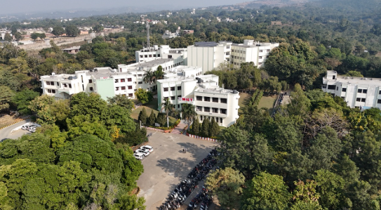

3.SHRI VESHNO DEVI UNIVERSITY
- Type: Public, Residential Technical University
- Established: May 12, 1999
- Location: Near Katra, Reasi district, Jammu & Kashmir
- Funding: Funded by Shri Mata Vaishno Devi Shrine Board and UGC
- Total Estimated Fee for B.Tech (2025-26):Around ₹2,29,746.
  - Tuition Fee: ₹1,41,240.
  - Annual Fee: ₹17,500.
  - One-Time Charge: ₹12,750.
  - Hostel Charge: ₹20,000 (if availed).
  - Security Deposit: ₹10,000.
  - Mess Charge: Tentative, with the final amount to be confirmed during registration.
- Accreditation: UGC, NAAC, and recognized by AICTE and the Council of Architecture
Academics:
- Programs: Offers undergraduate, postgraduate, and PhD programs across various faculties.
- Key Disciplines: Engineering, Management, Architecture, Science, Philosophy, and more.
- Admission: For B.Tech programs, candidates typically need a 10+2 with PCM and must qualify for JEE Main or CUET UG.
Campus & Facilities:
- Campus: An urban campus spread over 470 acres.
- Accommodation: Provides residential facilities with multiple hostels for boys and girls.
- Medical Services: A medical aid center with a clinical laboratory, dental unit, physiotherapy, and an ambulance is available.
- Guest House: A guest house with well-appointed rooms and suites is available for visitors.
Rankings & Recognition:
- NIRF: Ranked among the top universities and engineering institutions in India.
IMAGE: https://share.google/images/mhQ2NRTpDTnZKv2Xc
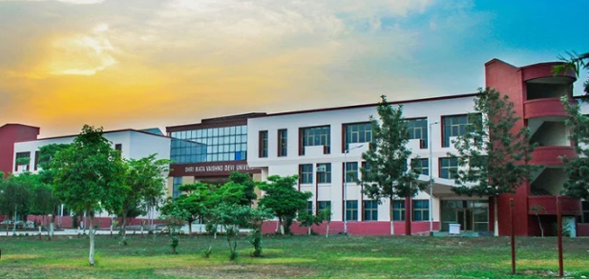

4.CENTRAL UNIVERSITY OF JAMMU
  - Establishment: August 8, 2011, under the Central Universities Act, 2009.
  - Location: Near Village Rahya – Suchani (Bagla), Samba district, Jammu & Kashmir.
  - TUITION FEE : UG Programs:Annual costs can range from approximately ₹20,000 for B.Voc to potentially higher for B.Tech.
  - PG Programs:Fees for Master's and Ph.D. programs tend to be more economical, with some MA fees being as low as ₹19,560

  - Campus: Spans 610 acres.
  - Accreditation: Recognized by the University Grants Commission (UGC) and has a "B++" Grade from NAAC.
  - Programs: Offers various programs including undergraduate (UG), postgraduate (PG), integrated, Ph.D., and certification programs across multiple disciplines.
Academics and Programs
The university provides education in:
  - Life Sciences: Including integrated B.Sc. + M.Sc. courses.
  - Engineering: Offering B.Tech., M.Tech., and Ph.D. in Computer Science and Engineering and Electronics and Communication Engineering.
  - Humanities & Social Sciences: Including programs in Social and Behavioural Sciences, Languages, and more.
  - Business Studies: Offering MBA and other management courses.
  - Other Disciplines: Mass Communication and Media Studies, Educational Studies, and National Security Studies.
Infrastructure and Facilities
  - Modern Facilities: State-of-the-art laboratories, a well-stocked, fully automated central library with an RFID system.
  - Student Services: Vibrant student facilities, workshops, seminars, and cultural events.
Admissions and Placements
  - Admissions: Primarily through the Central Universities Common Entrance Test (CUET) for UG courses and other entrance exams for PG and doctoral programs, according to the program and year.
IMAGE : https://share.google/images/HYUsMyZao9HZyHcBZ
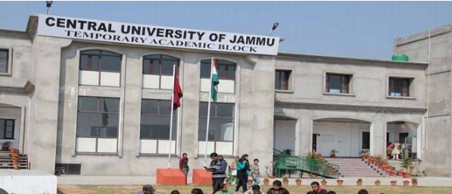

5. IIT JAMMU
- Established:2016
- Location:Jagti, near Jammu city, on National Highway-44
- Campus Size:400 acres
- National Ranking:62nd in Engineering (NIRF 2024)
- Mentorship:Mentored by IIT Delhi in the early stages
Academics & Admissions
- Programs Offered:
  - B.Tech in several specializations
  - M.Tech in multiple specializations
  - Ph.D. in several specializations
- B.Tech Admission:Requires at least 75% in 10+2 and a competitive JEE Advanced score.
Campus & Facilities
- Infrastructure:Modern classrooms, advanced laboratories, and a 375-seater auditorium.
- Research:Central Instrumentation Facility (SAPTARSHI Labs) and dedicated centers for research and innovation.
- Student Life:A fully functional hostel, dining hall, gym, various sports facilities (football, basketball, badminton), and student clubs.
Career & Placements
- Placements:Over 85% overall placement rate, with many students pursuing higher education nationally and internationally.
- Internships:Opportunities for national and international internships through various MoUs with organizations in Asia, Europe, and Australia.
Cost & Financial Assistance
- Tuition Fee:Varies based on parental income.
- Scholarships:SC/ST students and those from families with an annual income of less than ₹5,00,000 may be eligible for fee waivers and other facilities.
IMAGE : https://share.google/images/JDmCy7MCwh4K3zaxU
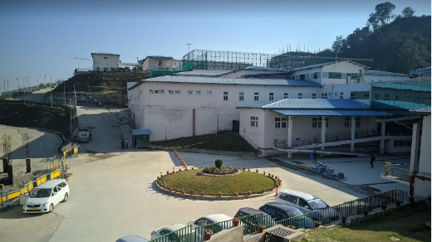

6.BEE ENN College of Nursing
- Location:Chak Bhalwal, Jammu
- TUITION FEE :
B.Sc. in Nursing
Total Tuition Fee:INR 3,00,000 for the entire 4-year course.
Post Basic B.Sc. in Nursing
Total Tuition Fee:INR 1.5 Lakh for the 2-year course.
General Nursing and Midwifery (GNM)
Total Course Fee:INR 6,00,000.

- Established:1998
- Affiliation:University of Jammu
- Approvals:Approved by the Indian Nursing Council (INC), J&K State Nursing/Paramedical Council, and the J&K State Government.
- Type:Private college
Programs Offered:
- B.Sc. Nursing:A degree course offered in affiliation with the University of Jammu.
- Post Basic B.Sc. Nursing:Another degree course for registered nurses.
- M.Sc. Nursing:A postgraduate degree program.
- General Nursing & Midwifery (GNM):A diploma course offered through the J&K Paramedical & Nursing Council.
B.Sc. Nursing Eligibility (Typical):
- Age:At least 17 years old (by December 31st of the admission year), upper age limit is 35 years.
- Domicile:Must be a domicile of the Union Territory of Jammu & Kashmir or Ladakh.
- Education:Passed 10+2 (Class 12) with Physics, Chemistry, Biology, and English.
- Marks:Minimum of 45% marks in PCB for open merit, 40% for reserved categories.
- Fitness:Medically fit.
IMAGE : https://share.google/images/9MuqhVlwMIbF5OWKp

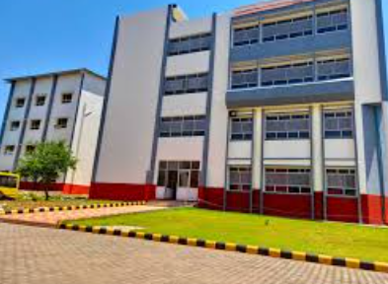

7.GOVERNMENT COLLEGE FOR WOMEN ,JAMMU
- Location:Gandhinagar, Jammu- 180004, Jammu and Kashmir, India
- Contact:0191-2435158, 2433614
- Affiliation:Affiliated with the University of Jammu
- TUITION FEE :
B.A.:Approximately ₹28,560 (Total Fees)
B.Sc.:Around ₹32,760 (Total Fees)
B.Com.:Approximately ₹29,510 (Total Fees)
BCA:Around ₹32,130 (1st Year Fees)

- Accreditation:Approved/Accredited by the National Assessment and Accreditation Council (NAAC)
Facilities & Features
- Hostel:A dedicated girls' hostel with a proper mess is available.
- Library:A well-stocked library facility is located in the heart of the academic complex.
- Laboratories:Equipped laboratories for various subjects including Physics, Chemistry, Zoology, Botany, and more.
- IT Infrastructure:Excellent IT infrastructure is available for students.
- Cafeteria & Auditorium:Adequate canteen facility and a 750-seater, air-conditioned auditorium are present.
- Transport:Bus facility is available for students.
- Extracurriculars:The college encourages participation in sports, theatre, debate, music, arts, and community service.
For Prospective Students
- Admission:Admission to various programs is based on merit obtained at the undergraduate level, along with other selection criteria.
IMAGE : https://share.google/images/RwSe1umvuouCwjQcQ


8. FACULTY OF LIFESCIENCES , UNIVERSITY OF JAMMU
- Type:Public/Government Institute
- Location:Jammu, Jammu & Kashmir
- Year of Establishment:1971
- Accreditation:NAAC Grade 'A+'
- TUITION FEE :
Sciences:
- M.Sc. in Microbiology
  - Total Tuition Fee (2 Years): ₹3.63 Lakh
- M.Sc. in Botany
  - Total Tuition Fee (2 Years): ₹4.84 Lakh
- M.Sc. in Zoology
  - Total Tuition Fee (2 Years): ₹4.84 Lakh
- M.Sc. in Environmental Science
  - Total Tuition Fee (2 Years): ₹4.84 Lakh
- General Range
  - Tuition Fees (2 Years): ₹3.63 L - ₹4.84 L

Academic Structure
- Courses Offered:M.Sc. and PG Diploma
- Specializations (M.Sc.):Includes Microbiology, Botany, Zoology, Biochemistry, Human Genetics, and more.
- Duration:M.Sc. programs are typically 2 years, while PG Diplomas are 1 year.
- Mode of Study:Full Time
Admission Details
- Accepted Exam:CUET-PG
- Eligibility:A bachelor's degree with a minimum of 50% marks is generally required for both M.Sc. and PG Diploma courses.
Infrastructure & Facilities
- The Faculty boasts state-of-the-art infrastructure and various facilities.
IMAGE : https://share.google/images/wn780BRBIuG7LnhAG

